**Database management system Lab CSE-403L**

**Semester:6th**



**Lab Report # 6**

**Submitted By:** *Zainab Khalid*

**Registration No:***19PWCSE1743*

**Section: A**

**Submitted to:** *Mam Naina Said*

**Department of Computer Systems Engineering**

**University of Engineering and Technology Peshawar**

**Task 7.1**

Create a simple calculator using php. The calculator should collect the operands as well as the

operator from the user using html form. (hint : Use Switch).

**Code:**

<!doctype html>

<html lang="en">

<head>

    <!-- Required meta tags -->

    <meta charset="utf-8">

    <meta name="viewport" content="width=device-width, initial-scale=1, shrink-to-fit=no">

    <!-- Bootstrap CSS -->

    <link rel="stylesheet" href="https://cdn.jsdelivr.net/npm/bootstrap@4.0.0/dist/css/bootstrap.min.css"

        integrity="sha384-Gn5384xqQ1aoWXA+058RXPxPg6fy4IWvTNh0E263XmFcJlSAwiGgFAW/dAiS6JXm" crossorigin="anonymous">

    <title>Calculator</title>

    <style>

    body{

        background-color: black;

        color: white;

    }

    .placeholder {

        height: 70px;

    }

    .container{

        box-shadow: rgba(0, 0, 0, 0.25) 0px 54px 55px, rgba(0, 0, 0, 0.12) 0px -12px 30px, rgba(0, 0, 0, 0.12) 0px 4px 6px, rgba(0, 0, 0, 0.17) 0px 12px 13px, rgba(0, 0, 0, 0.09) 0px -3px 5px;

    }

    .btn{

        box-shadow: rgba(0, 0, 0, 0.35) 0px 5px 15px;

        background-color:blue;

    }

    </style>

</head>

<body>

    <div class="container text-center justify-content-center border p-5 mt-5">

        <h1>Calculator</h1>

        <form action="calculator.php" method="GET">

        <div class=" col-12 align-items-center">

            <input class="col-7 placeholder" type="number" required name="first">

        </div>

        <div class=" col-12 align-items-center mt-2">

            <select class="col-7 placeholder" name="operator">

                <option>Add</option>

                <option>Subtract</option>

                <option>Multiply</option>

                <option>Divide</option>

            </select>

        </div>

        <div class=" col-12 align-items-center mt-2">

            <input class="col-7 placeholder" type="number" required name="second">

        </div>

        <div class="d-flex  col-4  mt-2">

            <input class="ml-auto btn btn-info col-5  placeholder " type="submit" value="Submit" name="submit">

        </div>

        </form>

        <?php

        if(isset($_GET['submit'])){

            $first_num = $_GET['first'];

            $second_num = $_GET['second'];

            $operator = $_GET['operator'];

            $result = '';

                switch ($operator) {

                    case "Add":

                       $result = $first_num + $second_num;

                        break;

                    case "Subtract":

                       $result = $first_num - $second_num;

                        break;

                    case "Multiply":

                        $result = $first_num * $second_num;

                        break;

                    case "Divide":

                        $result = $first_num / $second_num;

                }

                echo "<h1>The Result is : <span style='color: green;'>" . $result . "</span><h1>";

        }

        ?>

    </div>

</body>

</html>

**Output:**

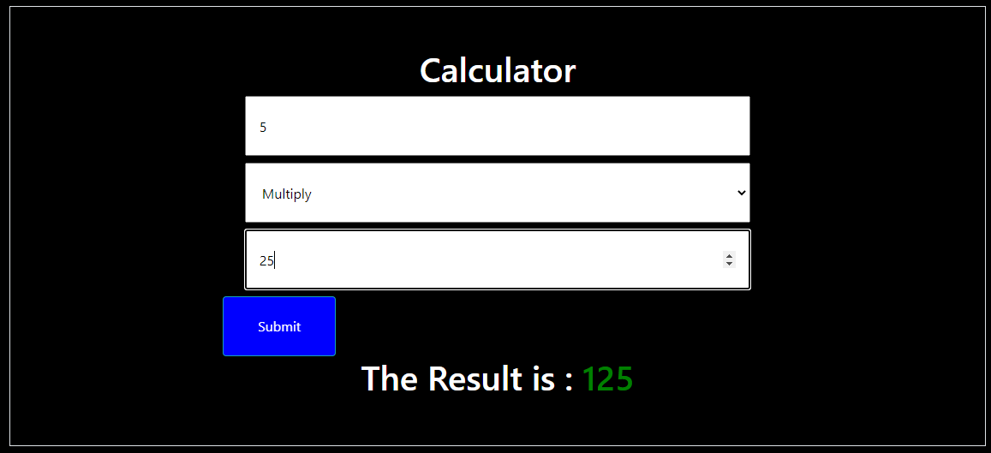

**Task 7.2**

Write a php function which creates the pattern as shown in the figure below. Please note that

the number of rows/cols should be dynamic. (i.e, the function can print the pattern depending

on the number of rows/cols passed to it)

**Code:**

<!DOCTYPE html>

<html>

<head>

    <title></title>

    <meta http-equiv="Content-Type" content="text/html; charset=UTF-8">

    <style>

    body{

        background-color:cornsilk;

        color: black;

    }

    input{

            margin-top: 10px;

        }

    form{

            padding:30px;

        }

    </style>

</head>

<body>

    <center>

    <form action="matrix.php" method="GET">

        <label for="row">Enter Rows: </label>

        <input type="number" name="row" required>

        <br>

        <label for="column">Enter Columns:</label>

        <input type="number" name="column" required>

        <br>

        <input type="submit" name="submit">

    </form>

    <table width="260px" cellspacing="0px" cellpadding="0px" border="1px">

        <!-- cell 270px wide (8 columns x 60px) -->

        <?php

        if (isset($_GET['submit'])) {

            $rowLenght = $_GET['row'];

            $columnLenght = $_GET['column'];

            for ($row=1;$row<=$rowLenght;$row++) {

                echo "<tr>";

                for ($col=1;$col<=$columnLenght;$col++) {

                    $total=$row+$col;

                    if ($total%2==0) {

                        echo "<td height=30px width=30px bgcolor='white'></td>";

                    } else {

                        echo "<td height=30px width=30px bgcolor='red'></td>";

                    }

                }

                echo "</tr>";

            }

        }

          ?>

    </table>

    </center>

</body>

</html>

**Output:**

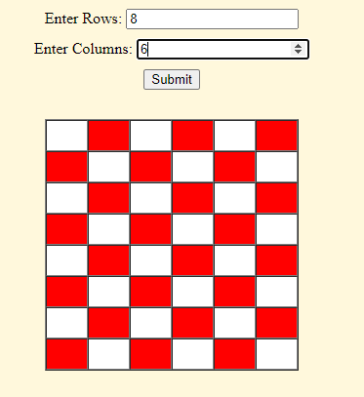

**Task 7.3**

Create a html form which collects information from students (name, email address, address,

gender, telephone number). The form must also have photo upload option. As soon as the user

clicks “submit” button, he is redirected to another page where the following message appears

“Thank you for providing the information. Your data has been submitted successfully”.

**Code:**

<!DOCTYPE html>

<html lang="en">

<head>

    <meta charset="UTF-8">

    <meta http-equiv="X-UA-Compatible" content="IE=edge">

    <meta name="viewport" content="width=device-width, initial-scale=1.0">

    <title>Form</title>

    <style>

        input{

            margin-top: 10px;

        }

        select{

            margin-top: 10px;

        }

        form{

            padding:30px;

        }

    </style>

</head>

<body>

    <center>

    <form action="thanks.html">

        <label>Name</label>

        <input type="text" required><br>

        <label>Email</label>

        <input type="text" required><br>

        <label>Adress</label>

        <input type="text" required><br>

        <label>Gender</label>

        <select required>

            <option>Male</option>

            <option>Female</option>

        </select><br>

        <label>Telephone Number</label>

        <input type="tel" required><br>

        <label>Attach picture</label>

        <input type="file" required><br>

        <input type="submit">

    </form>

</center>

</body>

</html>

**Redirection Page:**

<!DOCTYPE html>

<html lang="en">

<head>

    <meta charset="UTF-8">

    <meta http-equiv="X-UA-Compatible" content="IE=edge">

    <meta name="viewport" content="width=device-width, initial-scale=1.0">

    <title>Thanks</title>

</head>

<body>

    <center><h1 style="color:red">“Thank you Zainab for providing the information. Your data has been submitted successfully”</h1></center>

</body>

</html>

**Output:**

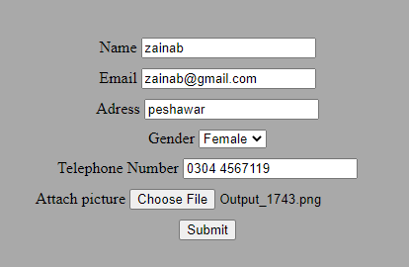



**Task 7.4**

Build an image gallery website using PHP without database. Your website must show all the

images in a given directory. Use bootstrap/CSS in your website. Please note that when a given

image is clicked, it enlarges it and shows in higher resolution. Also, your website should be

flexible enough to show the images when number of images are increased or decreased from a

given directory.

**Code:**

<!DOCTYPE html>

<html lang="en">

<head>

    <meta charset="UTF-8">

    <meta http-equiv="X-UA-Compatible" content="IE=edge">

    <meta name="viewport" content="width=device-width, initial-scale=1.0">

    <title>Document</title>

    <link href="https://cdn.jsdelivr.net/npm/bootstrap@5.2.0-beta1/dist/css/bootstrap.min.css" rel="stylesheet"

        integrity="sha384-0evHe/X+R7YkIZDRvuzKMRqM+OrBnVFBL6DOitfPri4tjfHxaWutUpFmBp4vmVor" crossorigin="anonymous">

    <link href="./styles.css" rel="stylesheet">

</head>

<body>

    <div class="navContainer">

        <nav class="navbar bg-light" class="navbar">

            <div class="container-fluid">

                <span class="navbar-brand mb-0 h1">Image Gallery</span>

            </div>

        </nav>

    </div>

    <h1>

        Gallery

    </h1>

    <div class="ParentDiv">

        <div class="container">

            <?php

            $directory = "./img";

            $images = glob($directory . "/*.*");

            foreach($images as $image)

            {

                 echo "<img src=$image class=imgClass>";

            }

            ?>

        </div>

        <div class="popup-image">

            <span>&times;</span>

            <img src="./img/qwe.jpg" alt="">

        </div>

    </div>

    <script src="https://cdn.jsdelivr.net/npm/bootstrap@5.2.0-beta1/dist/js/bootstrap.bundle.min.js"

        integrity="sha384-pprn3073KE6tl6bjs2QrFaJGz5/SUsLqktiwsUTF55Jfv3qYSDhgCecCxMW52nD2" crossorigin="anonymous">

    </script>

    <script>

    document.querySelectorAll('.container img').forEach(image => {

        image.onclick = () => {

            document.querySelector('.popup-image').style.display = 'block';

            document.querySelector('.popup-image img').src = image.getAttribute('src');

        }

    });

    document.querySelector('.popup-image span').onclick=()=>{

        document.querySelector('.popup-image').style.display = 'none';

    }

    </script>

</body>

</html>

**Output:**

